# Problem 2 - Weaponsmith

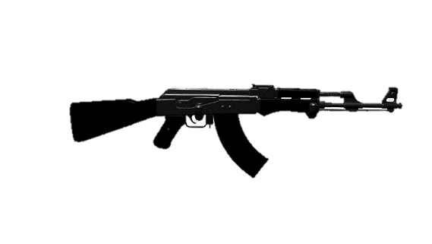

*You are a legendary weaponsmith. Heroes from all over the world come to you for the greatest weapons so they can rid the world of the greatest threats. But to craft a weapon you need to assemble its particles.*

You will receive parts of a **name** of a **weapon** - a line with **string** **particles**, separated by "**|**".

The particles will be in **mixed** order, and your task is to **align** them through given commands. You will be receiving them on separate **lines** until you are given the command **"Done"**. The **supported commands are:**

* **"Add {particle} {index}"**:
  + You should add the particle at **the given index** if the index is valid.
* **"Remove {index}"**:
  + You should remove the particle at **the given index** if the index is valid.
* **"Check Even"**:
  + **Print** the elements at **even** index positions, **separated by a single space.**
* **"Check Odd"**:
  + **Print** the elements at **odd** index positions, **separated by a single space.**

**An index is valid** when it is **between** **0** and **the index of the last element** **inclusive**.

When you receive **"Done"**,the weapon name is considered **correct,** and you should **print the particles** in their current order **joined together** in the following format**:** "**You crafted {weaponName}!**".

### Input

* On the **first line**, you will receive **parts** of the given weapon name in a **mixed** order **separated** by **"|".**
* On the **following lines**, until the **"Done"** command, you will be receiving **commands** in the **format described** above.

### Output

* Print the output needed as described above.

### Examples

|  |  |
| --- | --- |
| **Input** | **Output** |
| pa|Do|ha|mm|er Remove 0  Add om 1  Check Even  Done | Do ha er  You crafted Doomhammer! |
| As|hb|ri|ng|er  Remove 10  Add lo 5  Check Odd  Done | hb ng  You crafted Ashbringer! |
| Ta|es|to|la|ch  Add pa 8  Add ha 2  Remove 3  Done | You crafted Taeshalach! |